BASIC CONCEPTS ADVOCACY PROJECT
PHASE 2: FRANCES BAARD (2020-2021)

REPORT 6
As a result of Covid-19, the scheduled in-person training in Frances Baard district could not proceed, and we rapidly needed to find alternative methods of training. We therefore began to implement an online group-based training and have scheduled a comprehensive online training programme for the year. The 12 training sessions (2 sessions per domain) will be spaced out over the year allowing adequate time for implementation inside the classroom.

- Name of trainers and facilitator/s:
Louis Benjamin (trainer)
Gill Brand (facilitator)
- Date and Time:
Session 9: 09 November, 13h00-14h30
Session 10: 10 November, 13h00-14h30
- Foci of the sessions:
- Conveying plans for the implementation phase of the programme with all teachers and all learners in 2022
- Main focus was on the conceptual domain of Letter
- Register with names, including all officials:
Click here to access the GOOGLE SHEET
- Attendance Statistics:
Session | Date | Present | Apologies | Absent
11 | 09 Nov | 51 (91%) | 1 (2%) | 4 (7%)
12 | 10 Nov | 40 (71%) | 6 (11%) | 10 (18%)
*Number of catch-up views of the recorded session: Session 10 = 10 & Session 12 = 13

- Evaluation of training: 59% of attendees drawn from all of the teacher clusters (#6) responded.

i) Rate the training sessions: -
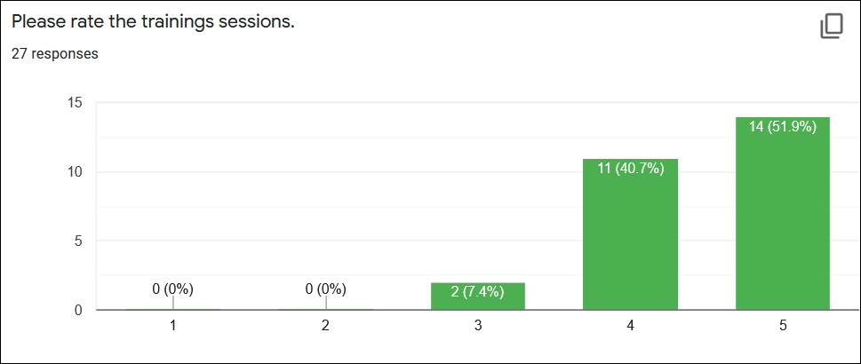

Scale: 1= very poor | 2 = poor | 3 = average | 4= good | 5= excellent

93% of the teachers rated the overall training as either excellent (52%) or good (41%), while two teachers (7%) rated the session as average.

ii) Rate the quality of the information presented: -
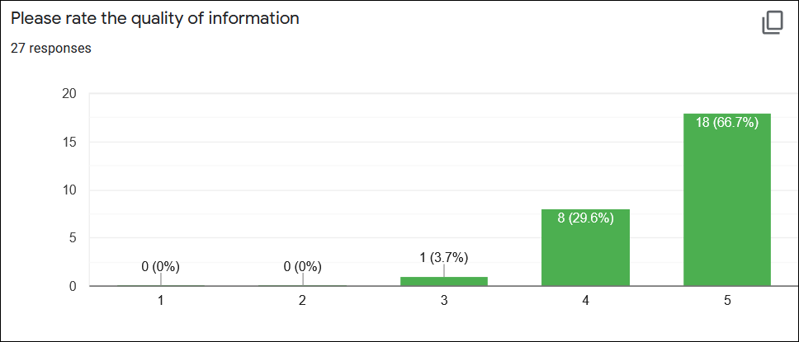
Scale: 1= very poor | 2 = poor | 3 = average | 4= good | 5= excellent

96% of the teachers rated the quality of the information as either excellent (67%) or good (29%), while one teacher (4%) rated the information as average.

iii) Rate your interest in the Basic Concepts Programme:-

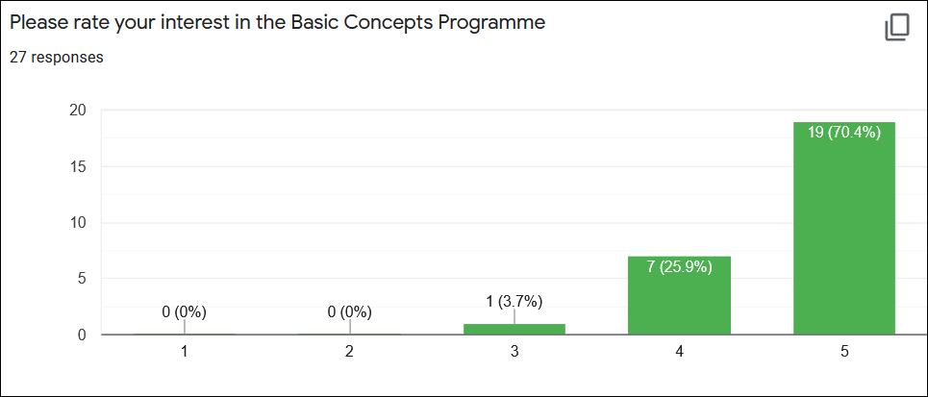
Scale: 1= very low | 2 = low | 3 = average | 4= high | 5= very high

96% of the teachers rated their interest in the Basic Concepts Programme as either very high (70%) or high (26%), while one teacher (4%) rated her interest as average.

iv) Rate your motivation to implement the BCP in your class: -

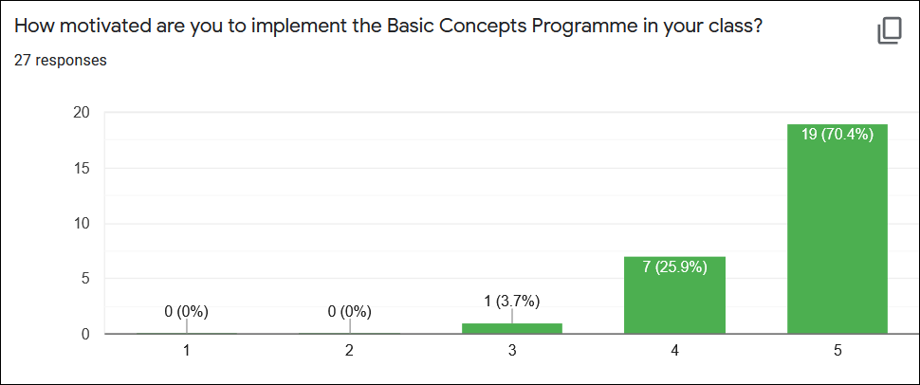
Scale: 1= very low | 2 = low | 3 = average | 4= high | 5= very high

96% of the teachers rated their motivation to implement the BCP as either very high (70%) or high (26%), while one teacher (4%) rated her motivation to implement the programme as average.

v) Rate the quality of your internet connection:-
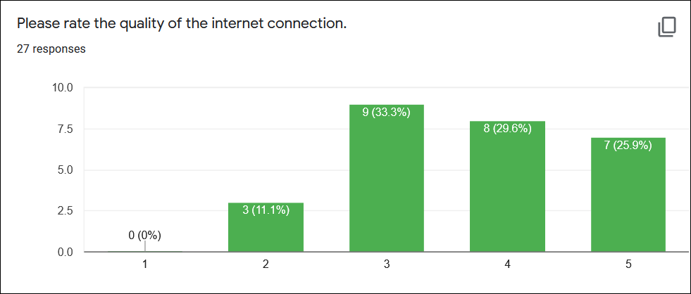
Scale: 1= very poor | 2 = poor | 3 = average | 4= good | 5= excellent

56% rated their internet connection as either good (30%) or excellent (26%), 33% rated their connection as average, while 11% rated their connections as poor.

- General Comments: -
i) The overall feedback from the teachers about the training was highly positive. The following verbatim qualitative comments were made about the current training sessions:-
- I am so motivated by the BCP. I'm excited to start with letter at the beginning of 2022, GOD willing. Thank you so much to the Basic Concepts team.
- The quality of the information is very good and interesting… I can't wait to interact with my groups in the classroom.
- I enjoyed the training. I have learnt a lot. Our Grade 1’s next year will be better.
- I liked the involvement during the sessions and also the practical work we do after the sessions… We are given a chance to implement in class what we did at the sessions. ❤️
- The training was good and I have learned a lot about Basic Concepts… they are useful for your planning as a teacher in the class.
- BCP is a very helpful programme that can be implemented and integrated into the classroom routine. It can be integrated within all 3 subjects of the Grade R programme.
- The training was very interesting and I learnt a lot… we now need time to do the practical activities.
- Everything was excellent and it is good that we now have more classroom resources.
- This session was one of the best... as we are (currently) busy doing letter in class and it helps me to improve.
ii) The average attendance at both number training sessions was very good (81%). In addition, we also had 23 views of the recorded sessions. This would bring the participation levels at these sessions to over 100%! These were once again very well supported sessions.
iii) The training sessions again focussed on a new conceptual domain for this group of project teachers. This was the 6th and the last conceptual domain of the programme, which will now be introduced to the learners inside the classes before the end of the year.
iv) The teachers were sent training materials (training notes, A3 laminated small group activities as well as associated workbook templates) before the current training sessions.
v) While the majority (89%) of the participants rated the internet connections as satisfactory, good or excellent, there were 3 teachers (11%) who did seem to experience significant problems. The recordings of the sessions might also be helpful for those who had difficulties with viewing the live session or could not attend for some reason.
vi) The overall levels of interest in the BCP and motivation to implement the programme remains very high (96%).

- Conclusion
This was both a very successful and well attended training. The average attendance at the training sessions (81%) was again very good; the average attendance at the previous sessions ranged between 70% to 85%. We were also very pleased with the overall positive feedback received from the teachers.

We have been encouraged with the very quick uptake of the domain inside the classes after the training. See photos below of work that has already been done by the teachers with their learners:-
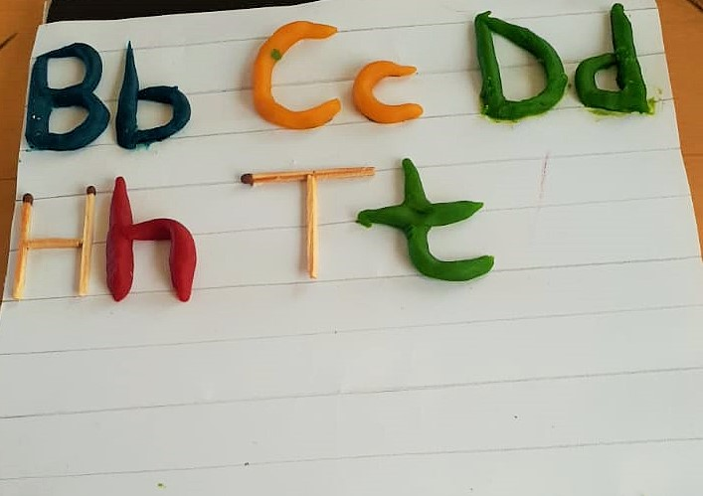
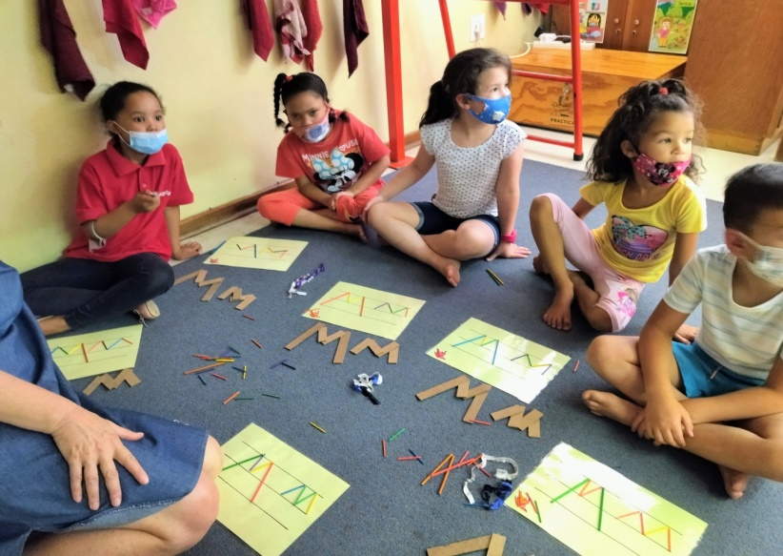

The focus will soon shift to the mentoring and support of the project teachers inside the classrooms. The main emphasis of the project next year (2022) will shift to the implementation of the programme with all Grade R learners. The learners who received the BCP intervention in Grade R in 2022 from trained mediators will be tracked and evaluated when they start Grade 1 in 2023.

