

NAMAQUA EDUCATION DISTRICT (2016-2017)
A Basic Concepts Project for Grade R Practitioners and NCDOE Officials

Field Visit 6:
Information Sessions for Officials
(14+15 August 2017)

Mentoring Teachers & Training Officials to Mentor
(16-18 August 2017)

Aim of Project
The project aims to significantly improve the quality of teaching-learning in Grade R classes in selected clusters of the Namaqua District. The project is premised on the assumption that improved teaching and learning in Grade R will contribute towards improved learning in the Foundation Phase and particularly in Grade 1. The project focuses strongly on the development of Grade R teachers as mediators of learning experiences in order to develop learners’ language and conceptual understanding. District Officials have been trained to coach and mentor these teachers in their classes. The project also includes a team of officials from the Northern Cape Department of Education (NCDOE) who are being trained (Phase 1) to extend the project to all Grade R teachers in the province.

Information Sessions for Officials:

- 8 officials representing 3 districts and the head office in Kimberley attended the information sessions. One of the officials from head office was not able to attend owing to illness. An additional official from the Namaqua District also attended the sessions. (Four officials from the Frances Baard district again did not arrive for the visit and have consequently been deregistered from the course.)
- The main aim of the information sessions was to assist the officials to develop a deeper understanding of the programme and to prepare them further as mentors of the programme.
- The officials had been requested to prepare a draft presentation about the programme and to bring this with them to the sessions. A number of the officials had in fact already sent their draft versions ahead of the sessions for feedback. The officials continued to work on their presentations during these sessions.
- The presentations were developed with a variety of target groups in mind, for example parents, teachers, officials and provincial heads. The topics were varied and included:- i) Using the programme to develop language and mathematics in young learners, ii) A proposal to extend the Basic Concepts to all districts in the Northern Cape, iii) Using the Basic Concepts Teaching Model to Teach Rounding Off, and iv) Helping parents to develop the conceptual language of their children.
- The officials worked very diligently during the information sessions to improve the quality of their presentations and even started to practise the delivery of their presentation. The officials felt that they had made substantial improvements to their presentations during these sessions and seemed very encouraged with what they had produced.
- The officials from the Namaqua District assisted to support some of the provincial officials who needed additional help with their presentations.
- The information sessions were interspersed with additional input about the programme and the project and its history since its inception in the district.

Mentoring Teachers & Training Officials to Mentor:

Visit Statistics
- Number of teacher contact sessions including teacher observations and feedback sessions with teachers: 24 out of the total of 27 teachers were seen.
- Number of contacts with schools: 15 out of a total of 18 schools
- Number of local district officials involved in the visit: 2 out of 4 officials
- Two teachers had resigned since my previous visit, while one teacher who had been retrenched from a small school (Tweerivier Primary School) had been reemployed at one of the project schools. This was at a school where a teacher had recently resigned.

Visit Overview
- Provincial officials were divided into four teams, three of which were accompanied by a more experienced local district official or myself. A third district official was on sick leave. The teams did their visits on 16 and 17 August, while I was able to visit another two teachers on my way home on 18 August.
- A total of 24 teachers from 15 schools were visited. Only three teachers from different schools still need to be visited by the district office.
- It has also been recommended that three teachers who were visited receive additional support by the district team.
- The officials met after their visits to give detailed feedback about their observations. This was supported by video and photographic evidence that was gathered during the visits. The officials were required to mentor and to give feedback about at least two teachers. The officials were also requested to submit their observation sheets at the end of the visit.
- This was the third opportunity the provincial officials had had to observe and to give feedback about the teachers. During this visit however they were encouraged to play a much more active mentoring role with the teachers inside their classes.
- The afternoon feedback sessions with the officials were notable and showed a deepening understanding of the approach as well as the teachers who are implementing the programme.
- The officials started to identify aspects of the approach that went beyond mere performance and seemed to be aware of the more nuanced aspects of mediational teaching processes inside the classroom. For example, they seemed to recognise when sessions progressed more naturally and when they did not .They were also very conscious of language usage patterns within the classrooms. They started to become more familiar with the technical procedures and jargon of the programme.
- The feedback sessions also played an important role in helping to develop interventions to guide and support the teachers. At least one of the officials mentioned that she had attempted to coach one of the teachers during one of her class visits.
- The teachers were all busy with the conceptual domain of Position and had in fact been mediating this domain since the start of the term over the previous 5 weeks. The expectation for this visit was that a great deal of the positional language would have been mediated and that much of the conceptual language for the first three conceptual domains would be present.

***See the visit programme attached in Appendix 1 at the end of the report.
Observations of Mediation
- It was evident that some teachers had in fact already exceeded the expectations for the visit and had started to work with the sub-concepts of left and right on the position board.
- There were no teachers who were not implementing the programme, but some teachers need to implement the programme more regularly –see * below.
- It was notable during the visits that the learners had started to make use of positional language and could in most cases already begin to give complex positional instructions to their peers. This is a very demanding activity that requires the use of multiple instructions and often involves a variety of conceptual domains to accurately place a peg/cube inside the position board.
- The teachers were all well prepared for their sessions and were ready to begin as we entered their classes. Many teachers had their session planners with them during the demonstration sessions and referred to them occasionally during their sessions.
- The mediation of the sessions was done systematically following the steps of the Concept Teaching Model and in most cases the teachers were able to appropriately pace their sessions giving each of their learners a turn to verbalize and explain their answers.
- *In only three classes where there concerns about the teachers and their mediation and/or with the regular implementation of the programme.
- The physical environment of the classes was adequate. There were position word walls and posters in most classes, but in some classes there were no theme tables. The teachers seemed to find it a bit more difficult to create theme tables for position, but in some classes there were some very impressive examples of theme tables –see the pictures below.

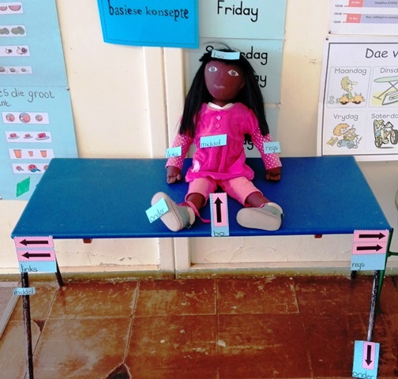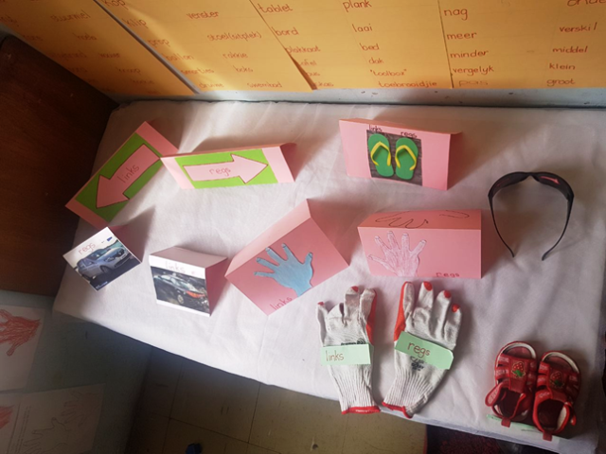

- The workbooks in most of the classes were described as good with multiple pieces (2-3) of work per sub-concept. There were a few classes where the quality of the work could be improved or where there could be more work done per sub-concept.
- In most of the schools with two or more teachers it was evident that these teachers were working closely together both in terms of their planning of their sessions (session planners) as well as the workbooks for their children.
- It was evident that the many of the teachers were confident enough to customize their mediation and had developed many of their own ideas/strategies to mediate their sessions. The sessions thus seemed different in many respects, but in other respects the teachers continued to use the main mediational routines that they had been taught and which have been found to be the most effective ways to teach these concepts.

Summary and Conclusion
This was a most encouraging visit to the project, both with respect to the practitioners in the classrooms and the officials who have been learning about the programme and the practical aspects of its implementation in the field. The practitioners have developed an ease with respect to the approach while their learners have started to respond in many classes with full descriptive and at times, even complex sentences. The departmental officials have grown increasingly more positive and enthusiastic about the programme which was evident in their presentations about the programme. The officials have in fact expressed the desire to expand the programme to their districts and teachers in the Northern Cape. It was therefore most pleasing that the Northern Cape government decided to meet with me in Springbok during the visit to discuss the expansion of the project in the Northern Cape in 2018 and have subsequently sent further correspondence outlining the scope of project.

The Namaqua District officials have continued to support the teachers since my last visit, and particularly those teachers who needed more support. There are still a few teachers who require additional monitoring and support and it seems that these are the same teachers who have previously been identified. We have however made tremendous progress with a number of other teachers who have been identified during past visits and now only have 3-4 teachers out of the entire group that still require strong support. There are in fact a number of teachers who have shifted so significantly in their attitude towards the programme that they have become role models of the approach.

The last project visit of the year will be October (16-20) and we look forward to seeing the continued progress of the teachers with the programme and their learners as they are exposed to the conceptual domains of letter and number. We look forward again to having the departmental officials accompanying us on this, the last official visit to the project. It is also our intention to have a graduation ceremony for all the project participants (teachers and officials) during the next visit to the project. We intend to invite all the project sponsors to join us in Springbok for this celebratory event.

Appendix 1

BASIC CONCEPTS PROGRAMME FOR VISIT 6

14 – 18 AUGUST 2017

14 + 15 August: Information meeting at Namaqua District office with provincial officials to review the Basic Concepts Programme. This will include presentations by the officials.
NAME | WEDNESDAY 16TH | THURSDAY 17TH | FRIDAY 18TH
ZELDA VOLLMER  WITH OFFICIALS OF OTHER DISRTICTS | OKIEP PRIMARY  FERDINAND BRECHER PRIMARY  MEETING | JAPSNOEJIES KLEUTERSKOOL  MEETING
JANE FIELDING  WITH OFFICIALS OF OTHER DISRTICTS | CONCORDIA PRIMARY  DR ISAK VAN NIEKERK PRIMARY  MEETING | PELLA RC PRIMARY  MEETING
MARY CLOETE  WITH OFFICIALS OF OTHER DISRTICTS | MATJIESKOOF RC PRIMARY  SPRINGBOK PRIMARY  CALUSBERG PRIMAY  MEETING | AGGENEYS PRIMARY  MEETING
LOUIS BENJAMIN  WITH OFFICIALS OF OTHER DISRTICTS | PORT NOLLOTH RC PRIMARY  PORT NOLLOTH PRIMARY  MEETING | FRANCOIS VISSER PRIMARY  MEETING | KAMIESKROON PRIMARY  JJ LAMBERT PRIMARY

