

KWENA BASIN PROJECT (2014-2018)
A Basic Concepts Project for Foundation Phase Teachers in Four Schools

Field Visit 8
13 March – 17 March 2017

Background
The project aims to systematically improve the language, cognitive and scholastic functioning of Foundation Phase learners from four multi-grade schools in the Kwena Basin by focusing on the quality of teaching and learning. The Basic Concepts Programme (BCP) is being used as a common approach to develop and extend the prerequisites for learning in English (First Additional Language). The teachers are being trained as mediators of the BCP and are receiving ongoing mentorship and support during the project.

Aim
The main purpose of this visit in Maintenance Year 1 was to ensure that the project teachers had started with the implementation of the programme and had appropriately set up their intervention groups inside their classes. The teachers completed the training process in September 2016. This would therefore have been the first year that they could fully implement the programme from the start to the end of the year. The teachers will be expected to continue independently with the implementation of the programme until my final visit of the year (September 2017). There will be no mid-year visit during this phase of the project. The visit included a meeting with the project educators at the start of the week to review progress and to set goals with teachers. A detailed presentation of the project results was given to the project teachers. (The presentation will be sent as an attachment to this report.)The teachers also received a file with copies of the relevant record keeping and planning documents for the year. The new classroom assistant (Mapule) also needed to be orientated to the project. She accompanied me to the schools during the week.
See the programme at the end of the report for a full breakdown of activities during this visit to the project.

Feedback From Teacher Meeting
Nine teachers as well as the new teaching assistant attended the meeting at Klipspruit Combined School on the first day of the visit to the project. Two of the multi-grade teachers from Umthombopholile and Phakama, who are currently involved in a new first additional language pilot project, were not able to attend the meeting. We consequently had to spend additional time with these teachers during our visits to their schools. The Grade R practitioner from Phakama has been employed by another school in the area. She has been replaced by a new, but untrained educator. This educator has not been involved in the project before. The new Grade R practitioner also attended the meeting – see more details about this educator below.

The teachers seemed very positive and encouraged by the improvements in their results. There was much interest from the teachers in the results as well as discussions on how to continue to improve on these results. A lot of focus was placed on increasing quality and quantity of the language interactions inside the classes. It was agreed to create vocabulary walls inside the project classrooms and to add to these walls on a regular basis as well as to share the pictures of the walls on the project What’s App group. See examples below of ‘Vocabulary Walls’ created during the visit.

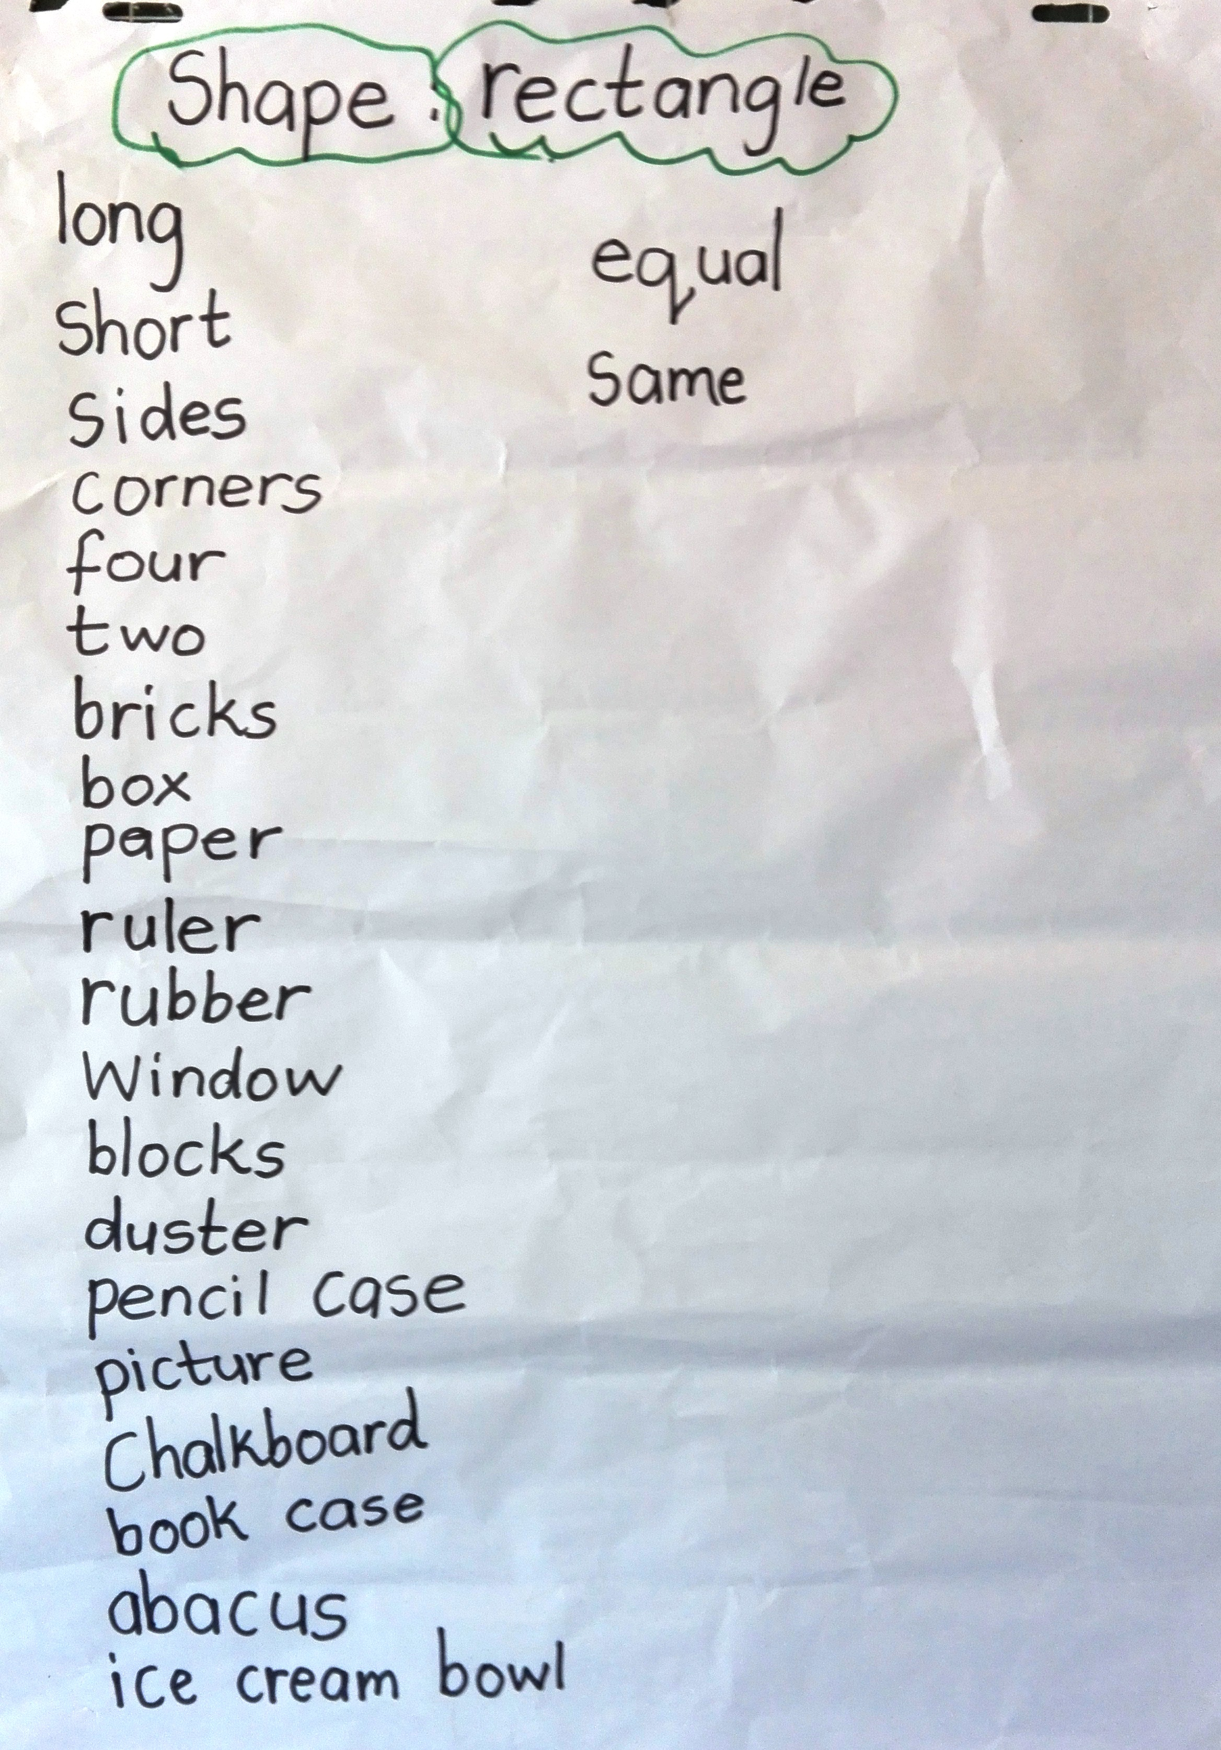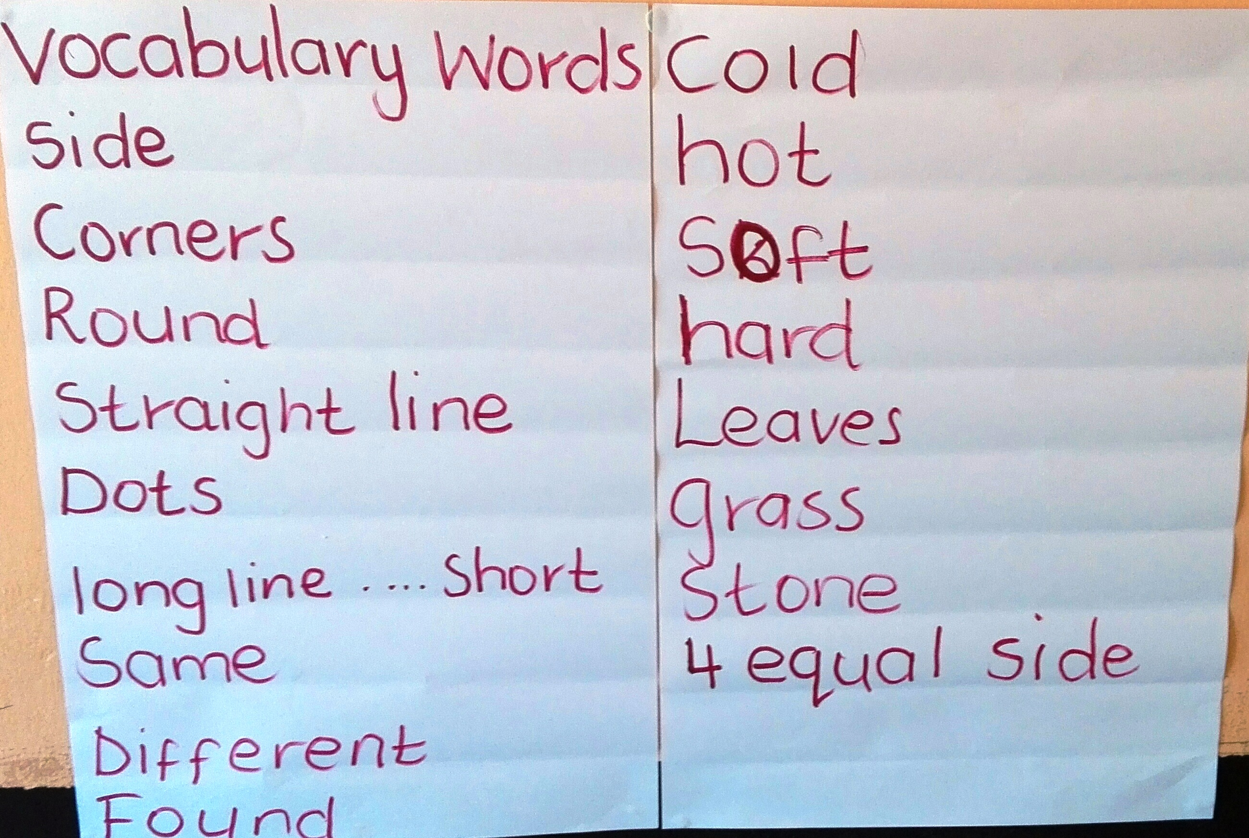
Grade 1 class Grade R class

The teachers seemed very positive about the project and ready to extend its impact on their learners. The teachers asked several questions during the meeting. There were some teachers who expressed concerns about their learners’ preparedness for learning this year, and in particular at one school where there is no Grade R class. The concerns might also be related to the number of learners in some of the classes. There were two multi-grade classes (Phakama and Umthombopholile) with almost 50 learners in each of their classes.

General Project Activities & Feedback from School Visits
Preliminary comments
- All the project teachers received at least one visit, while teachers at two of the schools received two class visits each.
- There were some difficulties coordinating visits at two of the schools because of Department of Education workshops with teachers during the week. We were however able to make changes to the visit programme and see all teachers. These changes resulted in our doing multiple visits (3) to these schools.
- Time was also spent with the new classroom assistant, preparing and coaching her to work alongside the project teachers.
- The new classroom assistant seemed motivated to fulfil her role in the classes, but at times needed additional prompting to initiate activities. She did however seem able to engage the learners while they were busy doing group work and kept them from distracting the teachers. She had shown commitment to her work over the last term and had already assisted at the three designated project schools.
- The project teachers were prepared for the visit and it was evident that they had already been working with their learners, many since the start of the year. This was an improvement compared with last year.
- The teachers were requested to run a short review session of Colour as well as to teach a shape that they were currently busy with. The teachers were also required to draw the shape with their learners.
- Many of the teachers had complied with the request to start their ‘vocabulary walls’ by the time we visited their classes (see above pictures) and all of the teachers seemed to have BC Workbooks for their learners.
- We found several classes had been cleaned up and reorganized and were looking better and creating a more conducive environment for teaching and learning.

Feedback from School Visits
Grade R: i.Enkeldoorn (n=6), ii.Phakama (n=20), iii.Umthombopholile (n=15)
- The sizes of the classes in the above schools varied between 6 – 20 learners. The largest class had 3 intervention groups while the smallest classes had 1.
- The largest class was also the class with the least experienced teacher. The teacher at Phakama had not been trained, but received some help from the class assistant (who had already observed several other teachers) and had been trying to do basic concepts with her learners. The teacher will be spending a day with an experienced Grade R teacher in the project. It was reassuring that the new teacher seemed genuinely interested and engaged in what she was doing.
- While it was most pleasing to see the development of one of the practitioners, it was concerning that the other practitioner had not yet made a good start to the year.
- On the whole however, the teachers seemed to be reasonably well-prepared for teaching this year.

Grade 1: i.Enkeldoorn (n=13), ii.Phakama (n=12), iii.Umthombopholile (n=29), iv.Klipspruit (n=30)
- The sizes of the classes in the above schools varied between 12 – 30 learners. The number of intervention groups at these schools varied between 2 - 4 groups.
- The teachers at the schools had made a relatively good start with the programme. This was most evident in the domain of Colour, but they had not made as much progress with Shape- This is with the possible exception of one of the schools.
- The Grade 1s were starting to respond to questions in full sentences, albeit in a rather rigid fashion using frame sentences.
- We found that the depth of the responses of the learners was still limited in most of these schools and the learners would benefit from more regular intervention.

Grade 2 + 3: i.Enkeldoorn (n=12 + n=13), ii.Phakama (n=15 + n=18), iii.Umthombopholile (n=23 + n=22), iv.Klipspruit (n=25+23)
- With the exception of Klipspruit the above schools have multi-grade classes. At these schools different arrangements have been made to accommodate the complexity in these classes.
- The majority of the learners in these classes still receive intervention and the teachers often have a stronger group of learners that helps to model the language for weaker learners. The teachers also often combine learners from Grade 2 and Grade 3 into one group.
- It was evident that the Grade 2 and 3 learners had begun to use extended sentences and were in many cases already comfortable with the conceptual domains of Colour and Shape. The conceptual language of the learners from two schools was already impressive. We also saw evidence of the accuracy and precision that is required when drawing the shapes taught in the programme.
- The teachers of these grades have been requested to not only construct ‘vocabulary walls’ inside their classes, but to assist their learners to create dictionaries from these words.

Summary and Conclusion
In summary, the project teachers had been able to initiate the programme from the start of the year and continue with it independently. I was most impressed by the interest and motivation shown by most of the teachers in the programme. It was however evident in some classes that some teachers (mostly in Grade 1) should have been implementing more often. It might also be that learners in these classes started out with very poor conceptual knowledge as a result of poor progress in *Grade R last year.

*Note: Klipspruit does not have a Grade R class and Phakama now have an untrained teacher.

The rural context of the project presents enormous challenges to the teachers and the principals in particular. When there are disruptions in one part of the school the knock-on effect can be enormous in all other areas of the school. For example, if one teacher is absent other classes/grades will need to be combined until the teacher returns. I saw a class with three grades in one class when a teacher was absent. Such problems occur frequently and in my experience might even occur on a weekly basis. The disruptive effect on teaching and learning can be substantial. It seems that much time is lost in these small schools owing to inefficiencies of the system. This might partly explain why the project teachers struggle to keep pace with the implementation of the programme and the teaching of new sub-concepts each week. The teachers were approximately 2-3 three weeks behind the implementation schedule.

In general I was most satisfied with what has been achieved this year and cumulatively over the duration of the project. The teachers do however need to keep up with the implementation of the programme and to do so on a regular and consistent basis. It might therefore be a good idea for Jean to do a quick one/two day visit to all the teachers in the middle of the second term. My next visit to the project will be in September 2017 when we start to gather the second last set of data for the project.

_____________________________________________

Programme for Visit 8 (March 2017)

Date | Activity | Target Group + Number | Place/School
13 March 2017 | School Visit: Groupings, Time-Tabling and Teacher Mentoring | Project Teachers = 2 | Phakama Primary
13 March 2017 | Teacher Meeting | Number of participants = 9 + Louis + Mapule | Klipspruit Combined School
14 March 2016 | School Visit: Groupings, Time-Tabling and Teacher Mentoring | Project Teachers = 3 | Phakama + Umthombopholile Primary School
14 March 2016 | Planning meeting with classroom assistant | Classroom Assistant= 1 | Verloorenkloof Estate
15 March 2016 | School Visit: Groupings, Time-Tabling and Teacher Mentoring | Project Teachers = 3 + discussion with principal | Klipspruit Combined School
16 March 2016 | School Visit: Groupings, Time-Tabling and Teacher Mentoring | Project Teachers= 2 + discussion with principal | Enkeldoorn Primary
17 March 2016 | Follow-up School Visits | Project Teachers = 2  Project Teachers = 2 | Phakama + Umthombopholile Primary School
TOTAL NUMBER OF CONTACTS |  | 28
*Note: The above programme does not include informal discussions with Dr. Jean Place about the project.

