Date | Activity | Where | Who
05/11/2020 | Volunteer Training Programme | Segonyana (4) | Practitioners, Volunteers, JTG and Frances Baard Official and Dr Benjamin.
06/11/2019 | Team 1: School Visits | Gakgatsana (2) | Dr B/ Gloria/ Mamikie
 | Team 2 ; School Visits | Glenred (3) | Candy/ Beauty
 | Team 3: School Visits | Hotazel (2) | Olga/ Maggy
07/11/2019 | Team 1: School Visits | Deben (4) | Dr/Maggie/Candy
 | Team 2: School Visits | Robanyane (3) | Olga,Mamikie
 | Team 3: School Visits | Noordkaap (4) | Gloria, Beauty
08/11/2019 | Team 1: School Visits | Ipetlontle (2) | Dr B/ Olga/ Beauty
 | Team 2: School Visits | Wrenchville (2) | Maggie/ Moetsi
 | Team 3: School Visits | Masakhane (2) | Candy/ Gloria
 |  | Tot Schools: 10 Tot Teachers: 28
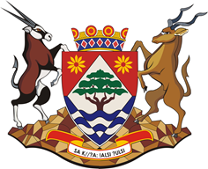

Basic Concepts Advocacy Project (2019-2023): Phase 1
A Project in Partnership With The Northern Cape Department of Education

Programme for Visit 4: JTG

