BC ADVOCACY PROJECT: PHASE 1 (2019-2020)
Pixley Kaseme Education District

Field Visit 3
19 – 23 August 2019
Aims of Visit
- To complete the formal training of this project’s teachers, officials and volunteers. This was achieved by giving two days of training in the fifth and sixth conceptual domains of Number and Letter.
- To continue mentoring and supporting teachers in their practice of the Basic Concepts Programme (BCP) by spending three days helping them with the BCP in their classrooms. Teachers were encouraged to continue implementing the BCP, complete mediation of Position and consolidate the first four concepts by the end of the term. They will start with the new domains next term, alternating Number and Letter daily.
- See the programme at the end of the report for a full breakdown of activities during this visit to the project.
1. Feedback from Training Sessions
Training Statistics-
Attendance | Training Day 5: Number | Training Day 6: Letter
Number of practitioners | 40 out of 44 | 41 out of 44
Number of local district officials | 1 out of 1 | 1 out of 1
Number of provincial & trainee officials | 2 out of 2 | 2 out of 2
Number of volunteers | 1 put of 3 | 1 out of 3
Number of other attendees | n/a | n/a
Total | 44 | 45

Comments on attendance statistics –
- One of the absent teachers had recently lost her husband. Two of the volunteers could not attend as the car they use had a problem. This was a pity as Louis had informed them that he would help with transport costs.
Analysis of qualitative feedback -
- Both days of training went well and the feedback was extremely positive. Comments reflected their enjoyment of it and that they gained ideas they can implement in class.

- Verbatim comments: Number
- I learnt the importance of using concrete objects to teach Grade R. The learners must feel and touch first.
- I enjoyed the ideas and answers that were shared.
- I have learnt that numbers are very important in our lives, because we use them in every second in every day. It helps us in problem solving. To be accurate. To know the symbols. Its universal. It helps us sort things / group / organise and arrange.
- I have learnt more about the importance of maths (numbers), that I can use it all day with my learners. Addition and subtraction are not difficult, it starts from Grade R.
- The training was clear. Everyone got a chance to ask or share what he knows.

- Verbatim comments: Letter
- I have learnt how to teach small children to read and write.
- I have the feeling that the programme will help us a lot. It also integrates into CAPS.
- I learnt some interesting activities that I can use in the classroom.
- This has made it very easy to introduce letter.
- This is a more interesting way to teach letters. I will implement it in my classroom.
- I never really knew how to introduce letter in so many different ways. Now I know how. Thank you.
- The facilitators could answer our questions. I am going to implement the knowledge and ideas gained. I liked the examples of using matchsticks, clay, etc. to learn to write letters.

General Comments about the training sessions –
- We used a new venue, La Provence Guest House. Initial problems with their projector were solved by resorting to our own one. Teacher participation was good; much questioning, discussion and learning took place. Motivation continues to be high.
- Each teacher received a wall implementation chart to encourage and remind her to implement the project. A reward system is being set up for the teachers.
- One disappointment was the absence of two of the volunteers. Louis will address this with them and train them when he meets with them later this year.

2. Mentoring Teachers and Training Officials/Volunteers to Support
Visit Statistics-
- Number of schools visited out of the total number of project schools: 7 out of 19
- Number of teachers visited out of the total number of teachers: 12 out of 44
- Number of officials who were part of the visits over 3 days: 3 officials per day
- Number of volunteers who took part in the visits over 3 days: 0 volunteers over 3 days

Overview of the school visits-
- The teachers were visited by one of two teams consisting of district and/or provincial officials and/or project team members and volunteers (2/3 members per team). Shaheeda Kamalie-Mali, Senior Education Specialist and co-ordinator of the BCP in the De Aar district, arranged the school visits. De Aar was the starting point each morning and feedback meetings were held there in the afternoons.
- A decision was made that this time more outlying schools would be visited as some had not been visited at all this year. It meant more time spent travelling but the visits were crucial to ensure widespread implementation of the programme.
- Generally, the classrooms we saw were adequately resourced, spacious enough and suitable for effective teaching and learning.
- All the teachers visited were still completing the fourth conceptual domain of Position. Some teachers had BCP vocabulary walls and BCP work on the walls, while others did not. Some of the BCP registers were not adequately filled in.
- It appears that the majority of teachers are doing the BCP regularly (see below). However, there are those that are still not, especially the teachers in outlying schools that had not been visited much. We have asked the volunteers to make a special effort to visit these teachers as they need strong encouragement and further mentoring to facilitate the consistent implementation of the programme. Some of the teachers expressed a need for more support and we hope that once they get this their mediation will improve and they will make faster progress. The teachers that are mediating well have told us that they can see the progress in their learners, especially in their understanding of the BCP concepts and their use of language. Most of the teachers still fall into the ‘average’ category, and are still ‘practising’ the BCP and the mediational approach and have not fully mastered either yet. Overall, most teachers are mediating the BCP with some degree of success. We hope that by the end of the year, the practitioners will have mastered the BCP and the use of mediation in their classrooms.

Mediational/teaching environment-
- The overall feedback indicated that about two thirds of the teachers had a good to reasonable grasp of the BCP and mediation. These teachers were familiar with the steps of the teaching model and mediational teaching. Their learners were familiar with colours, shapes and size, the conceptual domains that have already been completed. ‘Position’ is still being completed.
- About a third were still struggling with the BCP. They are not confident with the BCP steps and are still doing most of the talking and not encouraging enough use of language and thinking in their learners. Many of these teachers are in far-flung schools and have not received adequate support this year. We have urged the volunteers to do follow-up mentoring visits in the near future with them. Their learners continue to need encouragement to use full sentences and to respond individually with self-initiated ideas (instead of just repeating after the teacher).
- Feedback given to the teachers related to the following:
  - Workbooks were still not as we would like. They should let the learners draw more of their own work and use fewer photocopied activities.
  - BCP admin files need to be completed properly.
  - Encourage more learner talk and less teacher talk. Continue to ask open-ended questions, encourage and model the use of conceptual vocabulary and full sentences.
  - Encourage individual thought and responses and allow time for these.
  - Children not doing the BCP with the teacher must be given productive activities.

Frequency of programme implementation and motivation of teachers-

An anonymous survey was handed out to the teachers at the training (n=40). As shown in the table below the practitioners are generally implementing the programme between 3 and 4 times a week with an average number of 3 groups. Mentoring and support is adequate for most of the teachers although there were a few that feel they are not getting enough support. The vast majority believe they are developing as mediators and feel very positive about the BCP and that it is of benefit to them and their pupils.

Anonymous Feedback Question | Rating
Average Implementations per week | 3.7
Average number of groups per implementations | 3
I value the BCP & feel it helps | 4.43
I get enough support (Yes/No) | 88%
I am developing as a mediator & understand the BCP | 4.3
I would run the BCP more with more support (Yes/No) | 98%
My overall rating of my BCP experience | 4.1
Scale:
0: low/no/negative
5: high/yes/positive

3. Department of Education: District and Provincial
- There were numerous meetings and contacts with the DoE officials during the visit. After the daily school visits there was a feedback session with the project team, including the officials.
- Officials are very positive about the project and willing to help wherever they can.

4. Volunteers
- The district has three volunteers (the fourth and latest addition did not work out) and they have been visiting teachers and giving feedback. Only one volunteer attended this latest training, but Louis will give them all training when he sees them next term.
- The district official, who oversees the volunteers, says she is happy with them.

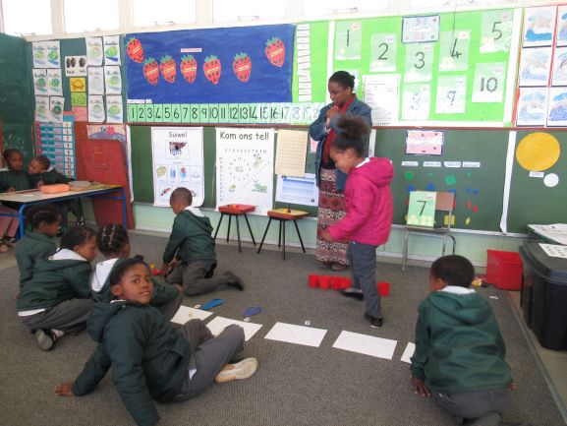
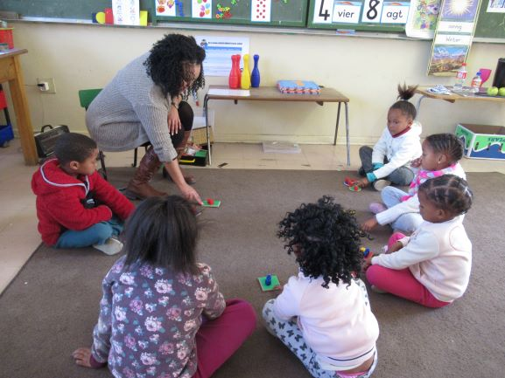

School visit – Mev De Beer – John Rossouw (Victoria West) Mev. Beeest – Canarvon Primary (Canarvon)

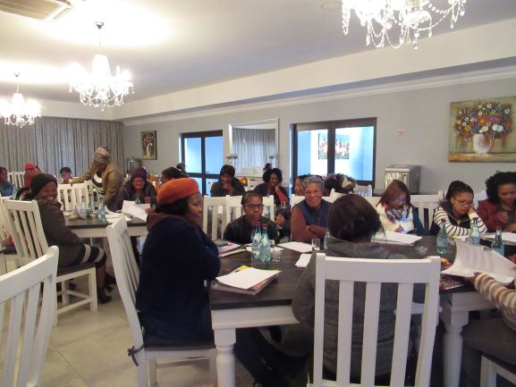
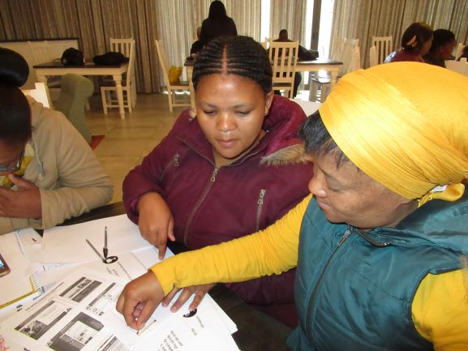

Training

5. Summary and Conclusion
- The official training is now complete for this cohort of practitioners. It was highly successful with excellent participation and engagement. The practitioners’ attendance at all six training days was 95% while the officials was 100% and the volunteers was 50%.
- Most teachers are implementing the BCP regularly in the Pixley Kaseme district. It is wonderful to see how some of their learners are communicating well and have a good understanding of their basic concepts.
- Those teachers that are not implementing regularly enough will be given more support and encouragement by the volunteers and officials. The What’s App group continues to play an important role in sharing ideas and assisting us to communicate with and encourage the teachers.
- The Northern Cape Department of Education continues to be an enthusiastic supporter of the project. We are hopeful that the project will not only upskill many of the educators and change the way they teach, but also help their learners be better prepared for school and thus improve their chances of academic success.

Appendix 1
Basic Concepts Advocacy Project: Phase 1 (2019 – 2020)
Pixley Kaseme and JTG
Programme for Visit 3: 19-23 August 2019
DATE | Activity | Participants | Time | Comments/Notes/Aims
19 August | Training | All practitioners, volunteers and officials | 9:00 – 16:30 (registration at 8:30) | Teachers to bring their files and a selection of workbooks with them. We only need 6 kits and pictures sets for the training. Workshop evaluation to be completed at the end of the training.
20 August | Training | All practitioners, volunteers and officials | 8:00 – 16:30 (registration at 7:30) | Teachers to bring their files and a selection of workbooks with them. We only need 6 kits and pictures sets for the session. Workshop evaluation to be completed at the end of the training.
21 + 22 Aug | School Visits | Number of visit teams: 2  Number of visits per team: 6/7  Total number of visits: 12 | 8am to the end of school day | 30-40 minutes per class visit. The focus of the visits should be on NUMBER, but also briefly review POSITION at the start of each session for 5-10minutes.Teachers not visited can be visited by volunteers after the visit.
21 + 22 Aug | Visit feedback at the district office | Officials, Volunteers and Project Team | 14h00-1600 | All class visitors bring their completed observation sheet with them to the feedback meeting to give feedback on their visits. Each person on the visit team should take responsibility for reporting back on at least one visit.
21 Aug | Meeting with District Officials | Project Team and District | 16h00-17h00 | To discuss planning for the way forward: teacher support, volunteers, dates for next visit, add new participants to what’s app group, etc. Take notes at this meeting.
22 Aug | Meeting with Volunteers | Volunteers, District Officials and Project Team | 16h00-17 h00 | To get feedback from volunteers and to plan the next set of visits to the teachers. Attempt to clarify and sort out any problems or make a note of these. Discuss the new observation sheet. Etc.
23 Aug | School Visits | Officials and Project Team | 7:30-10am – early start to get to schools at the start of the day | This is a shorter day and only limited visits to allow the project team and officials time to get back home by the end of the day. The local officials may continue with the visits after the project team has left.

