###### 14.30 – 16.00

###### Cape Teaching and Leadership Institute (CTLI)

Nooiensfontein Road, Kuils River

###### *Refreshments will be served at 14.30*

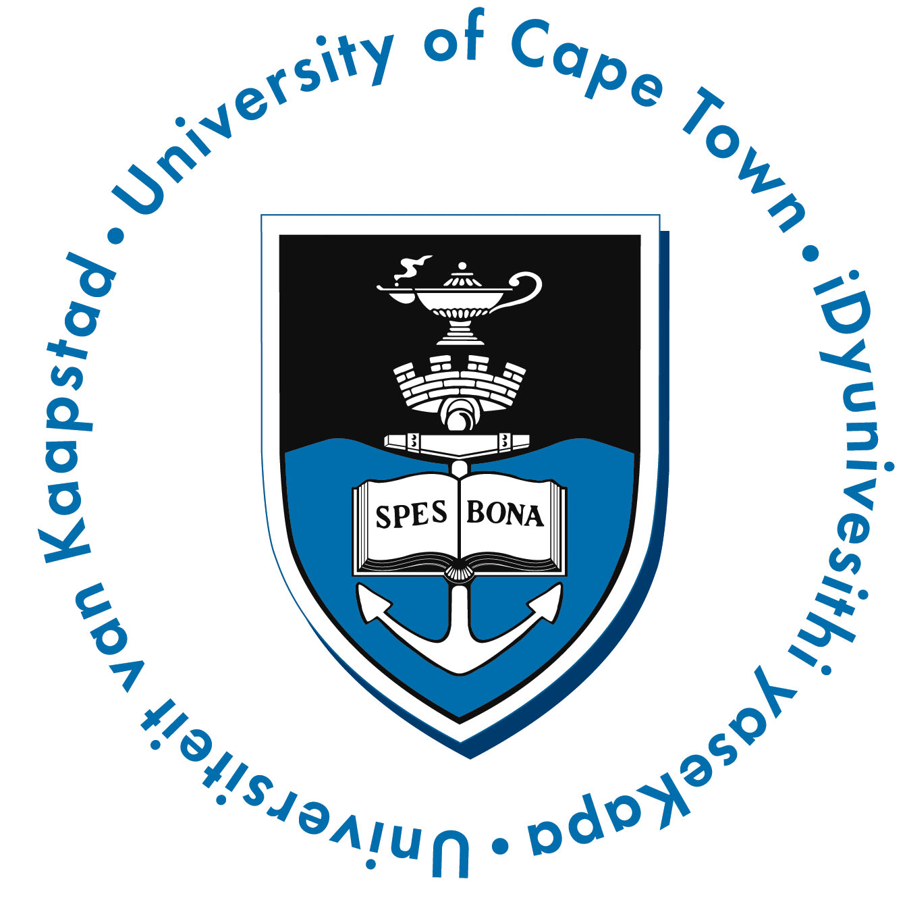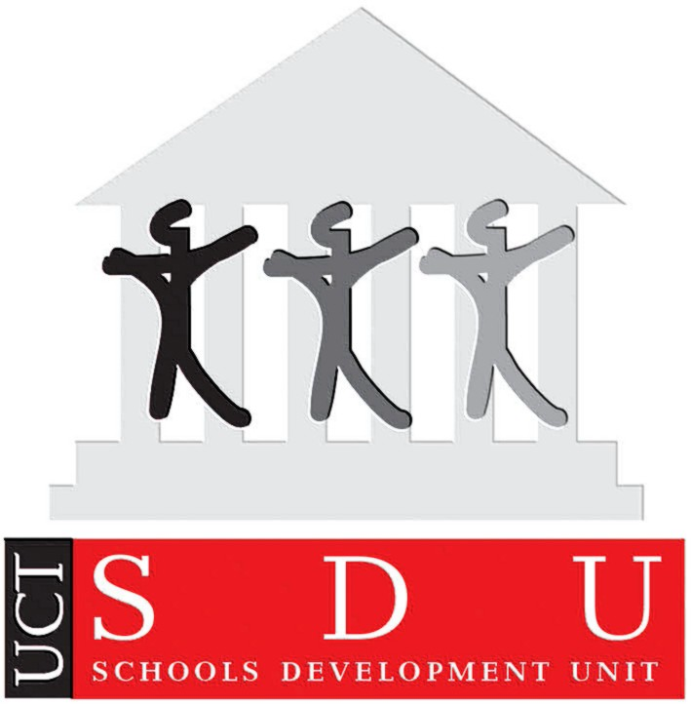

**23 January 2013**

###### **Special Thanks**

###### Teachers and Principals from the iKwezi schools

###### Western Cape Education Department (WCED)

###### Metropole East & North Education Districts

###### The DG Murray Trust

###### iKwezi Project Team

###### **Programme**

###### Welcome

###### Ms Ursula Esau

###### Address

###### Dr John Clark

###### Educator Response

###### MsMandisaYamiso

###### Presentation of Certificates

###### Basic Concepts Programme: Dr Louis Benjamin

###### Early Learning Resources Unit (ELRU): Ms Blossom Ngwevela

###### Schools Development Unit: Ms Tami Mhlati

###### Thanks

###### (MsDiane Hendricks)

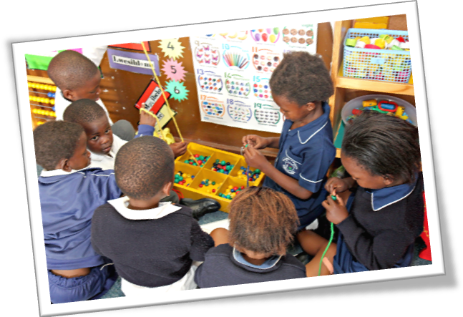

**iKwezi Project**

Certification Ceremony

Grade R and 1